Software Requirements Specification

Version 1.1

APRIL,8 2018

IShuttle



KODAH

TABLE OF CONTENT.

Introduction……………………………………………………………3

Scope……………………………………………………………………..4

Functional Requirements……………………………………….5

Extra Features………………………………………………………6

Interfaces……………………………………………………………….7

Conclusion………………………………………………………………9

INTRODUCTION

This Software Requirements Specification provides a complete description of all the functions and specifications of the iShuttle application designed by the KODAH group.

The expected audience of this document is the lecturer for software engineering third year,Mr Yankey and also the students who will use this system. This document is an updated version of the previous document SRS 1.0 and it brings an improvement on the previous version.

Diagrams in this document have been made as clear and simple as possible to be understood by anyone who picks up the document.

SCOPE.

The iShuttle app is designed for the students of Kwame Nkrumah University of Science and Technology as well as the shuttle drivers on campus.It enables the student to be able to locate where a particular shuttle is at any point in time,the destination of the shuttle and how long it will take the shuttle to get to where he/she is at that point in time.This version has been designed with better graphics than the previous and a more consistent user interface compared to the second.

FUNCTIONAL REQUIREMENTS.

Functional Requirements are those that refer to the functionality of the system, i.e., what services it will provide to the user.

|  |  |
| --- | --- |
| ACTIVITY | DESCRIPTION |
| Splash Page | It is used to indicate our brand to the students whiles some background processes load |
| Map Interface | It displays the map with driver location and bus destination |
| Registration page | Drivers who are first timers are required to register on this page with their secret code,user name and telephone numbers which is stored on an online database for later use |
| Decision Page | On this page the user selects if he/she is a student a driver or will want to access locateKNUST |
| Sign in | Drivers enter their phone numbers and password since they have been registered already. |
| Drivers Page | After the sign in process drivers are taken to an interface where they are required to specify their routes and destinations |

STUDENT.

MAP INTERFACE

DECISION PAGE

SPLASH PAGE

DRIVERS.

REGISTRATION PAGE

SPLASH PAGE

DECISION PAGE

SIGN IN

DRIVERS PAGE

EXTRA FEATURES.

In an updated version of the app we intend to work on a lot of extra features but as at now locateKNUST is the only feature being added to the app.

PURPOSE OF THE APP

LocateKNUST helps the student populace find buildings on campus which are not so popular.Its main target is for freshers and visitors who visit the campus and don’t know their way around.

HOW IT WORKS.

LocateKNUST has markers indicating the various buildings on campus and a blue dot indicating the user’s current location.It comes with a legend which when clicked tells the user what each marker stands for and buildings or places around it.

INTERFACES

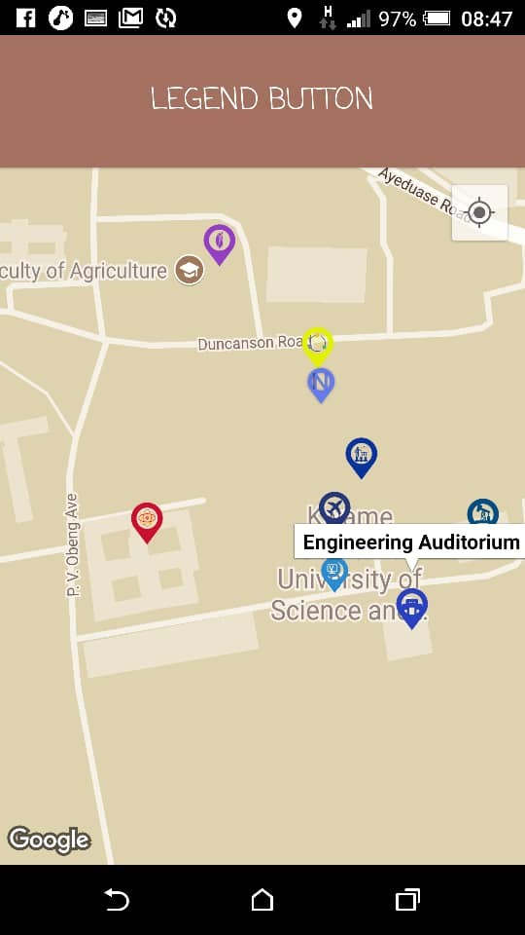 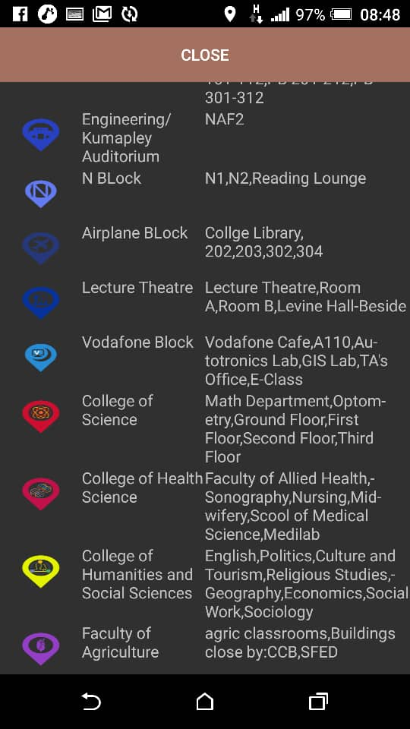

INTERFACES FOR ISHUTTLE

